# Big Bang Theory – IT17069564

First, I executed the Sheldon1. Then understood that there are 6 Phases in here

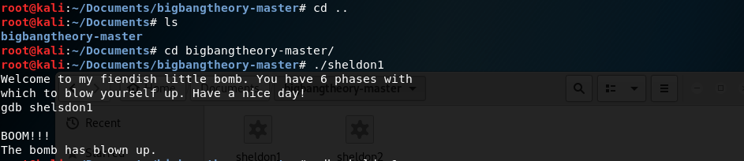

Then gave gdb shedon1 to get the assembly code. Then gave info functions command to get the available functions.

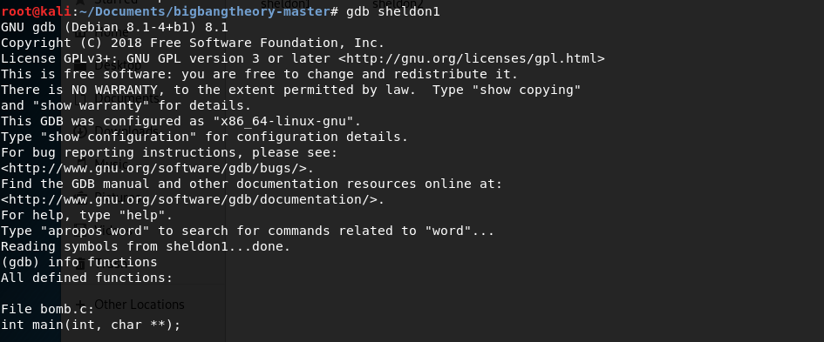

In there is a function name as “phase_1”. Due to when we 1st enter the password bomb has blown. I understand that there should be some condition that compare our input with it.

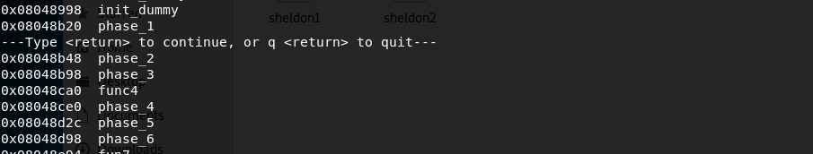

So, I added a breakpoint in the phase_1. Then disassemble the phase_1 to get the assemble code. 